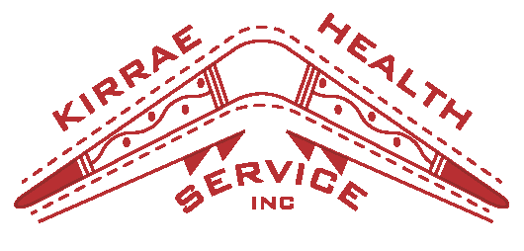

Social, Emotional and Wellbeing (SEWB) Program Worker
Key Selection Criteria – please address

KSC1 Acknowledge the need for a holistic approach to health to improve the SEWB of Aboriginal and Torres Strait Islander peoples

KSC2 Work collaboratively with the KHS SEWB team and with all other KHS programs and services

KSC3 Understanding the historical, social and cultural issues that impact on the SEWB of Aboriginal and Torres Strait Islander individuals, families and communities

KSC4 Ability to respectfully engage with clients, staff and external agencies.

KSC5 Good listening and organisation skills

