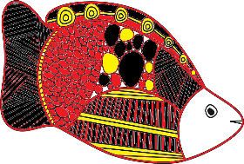
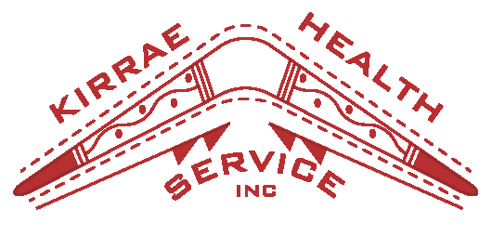

2022

Cough, cold, fever, runny nose, sore throat?
ANY symptoms at all, no matter how mild, get a COVID19 test immediately

Doctors

Dr Hall – Tuesday –6th

Dr Chandan – Tuesday 6th, 8TH

Dr Hedgland- Thursday 17th

Inside Newsletter
Individual Highlights:
Birthdays | 2
Reminder message | 3
New Staff Member | 4
Community Defib | 5
Slip Slop Slap | 6
Snake bite info | 7-8
Community surfing | 9
Playgroup | 10
HACC/CHSP | 11
Bingo | 12
World Diabetes day | 13
Men’s Group | 14
SEWB | 15-17
Groups Photos | 18-20
That’s Deadly | 21-23
Optus data breach info | 24-25
Sisters day out | 26
Career Counsellor | 27-28
LGBTQI+ | 29
Puzzle | 30
Recipe | 31
Color in
Calendar | 33
Feedback | 34

·

Birthdays

Sorry if any of the Birthdays are wrong. If so can you please come update your details at Reception.

Who we are

Wirann Ugle Hagan 1st
Billy McGuinness 1st
Kylie Harradine 1st
Grant McKenzie 2nd
Jessie Chatfield 4th
Crystal Litster 6th
Aliera Harrison 10th
Louise Wacket 11th
Isabella Harradine 11th
Allie Clarke 12th
Natasha McGuinness 13th
Lionel Chatfield 15th
Ty Clarke 16th
Deirdre Hart 21st
Casey Harradine 22nd
Skye Litster-Henry 22nd
Karina Fitzgerald 23rd
Travis Harradine 23rd
Trudy Clark 25th
Brian Davis 25th
Samuel Grinter 26th
Matt Morrison 27th
Teneshia Harradine 28th
Danny Chatfield 29th
Jamie-lee Leslie 30th
Shayla Chatfield 31st

Kirrae Health Service exists in order to Service the physical, mental and emotional health needs of the Framlingham Aboriginal Community and surrounds in a manner that is effective, Culturally sensitive and acceptable to the Community.

What services do we provide?

Community health
- Health workers
- GP’S & RN
- Optometry etc
- Chronic disease management
- Health checks & more

Home & community care - CHSP
- Assessment
- Home maintenance
- Social support groups
- Access to homecare and personal care
- Planned activity group

Children’s activities
- Playgroup
- Holiday program
- Koko blokes

Social emotional and wellbeing
program
- Advocacy support
- Counselling (individuals, families, children)
- Case management
- AOD

Thanks Deadly Walkers

Reminder

Just a friendly reminder if you do not give us prior notice of upcoming appointments we are unable to cover costs.
If you need us to transport you we need at least one weeks’ notice due to vehicle shortage.
If you require a petrol voucher, we require at least 24hrs notice.

Thanks for you cooperation!

Kirrae Health Service will be closed from the 22nd December and re-open on the 9th January

Emergency numbers

In an emergency dial 000 to access Fire, Police or Ambulance
Council (business hours)
8.30am – 5pm Mon-Fri
Phone: (03) 5559 4800
Council (after hours)
Call 5559 4800, follow prompts to leave message or to talk to our call centre about:
- Traffic hazards.
- Safety hazards.
- storm water drainage
- stock on roads
- stray dogs
- dog attacks
Hazards on designated highways (Caramut Road, Mortlake Road and Raglan Parade) are the responsibility of VicRoads.
VicRoads: 131 170
State Emergency Services (SES)
Flood & Storm Emergency – 132 500
Current Emergency Information
Water
Wannon Water Authority
Phone: 1300 926 666
Injured Wildlife
Phone: 13 000 94535
DEWLP hotline: 136186
RSPCA
RSPCA – Warrnambool Branch
Phone: (03) 5561 2591
RSPCA after hours
Phone: (03) 9224 2222

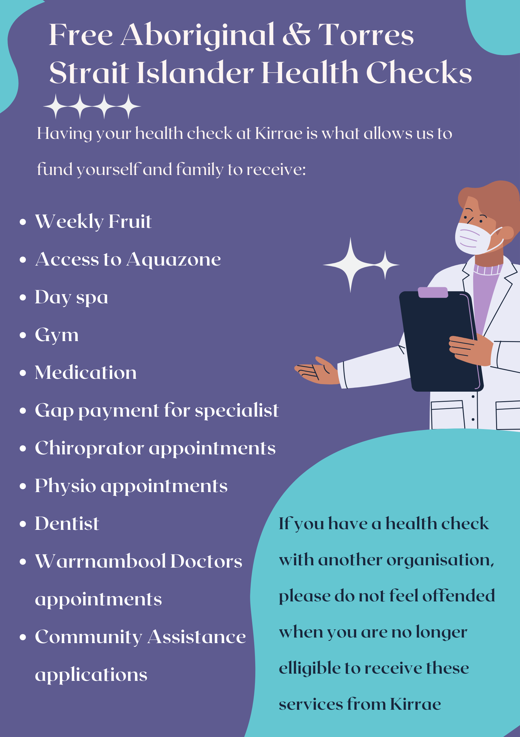
HACC/CHSP

Social Support Lunch - Tuesday 6th
Woolsthorpe Hotel @12pm

Community Christmas Lunch –
Wednesday 14th
Kirrae Health Service @ 12pm

Bingo- Wednesday 14th
Kirrae Health Service @ 11am to 2pm

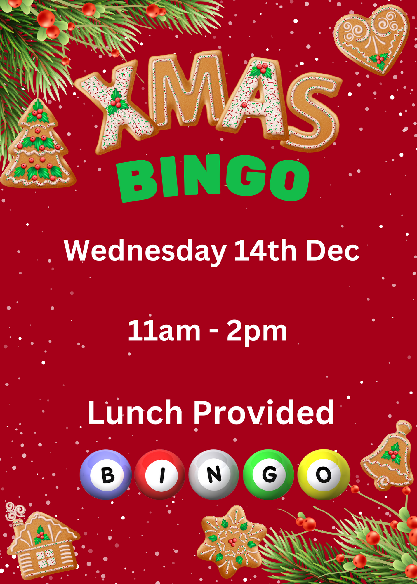
BINGO
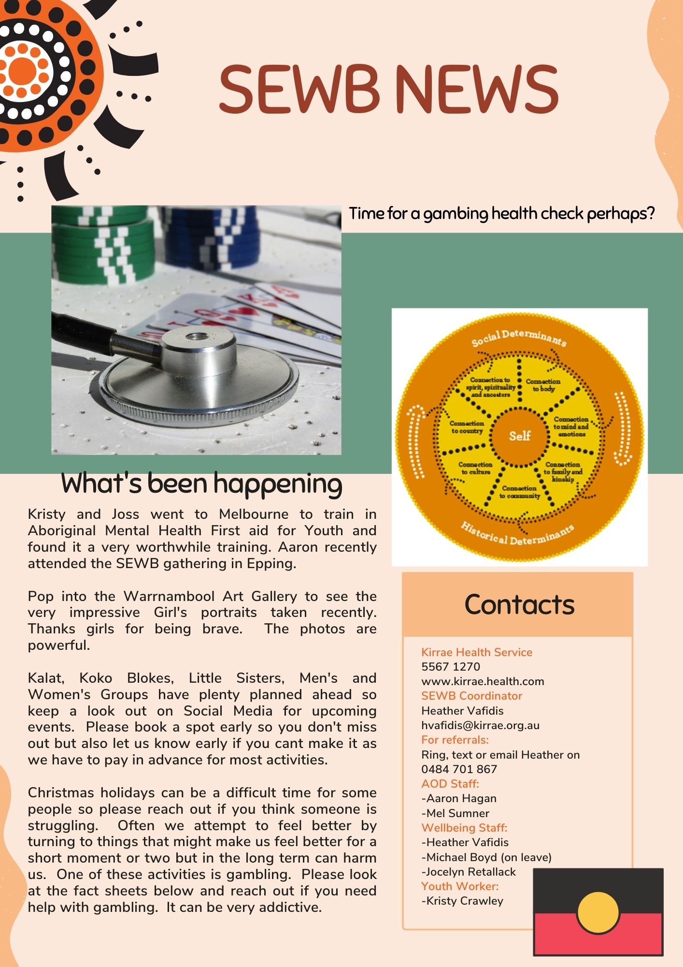
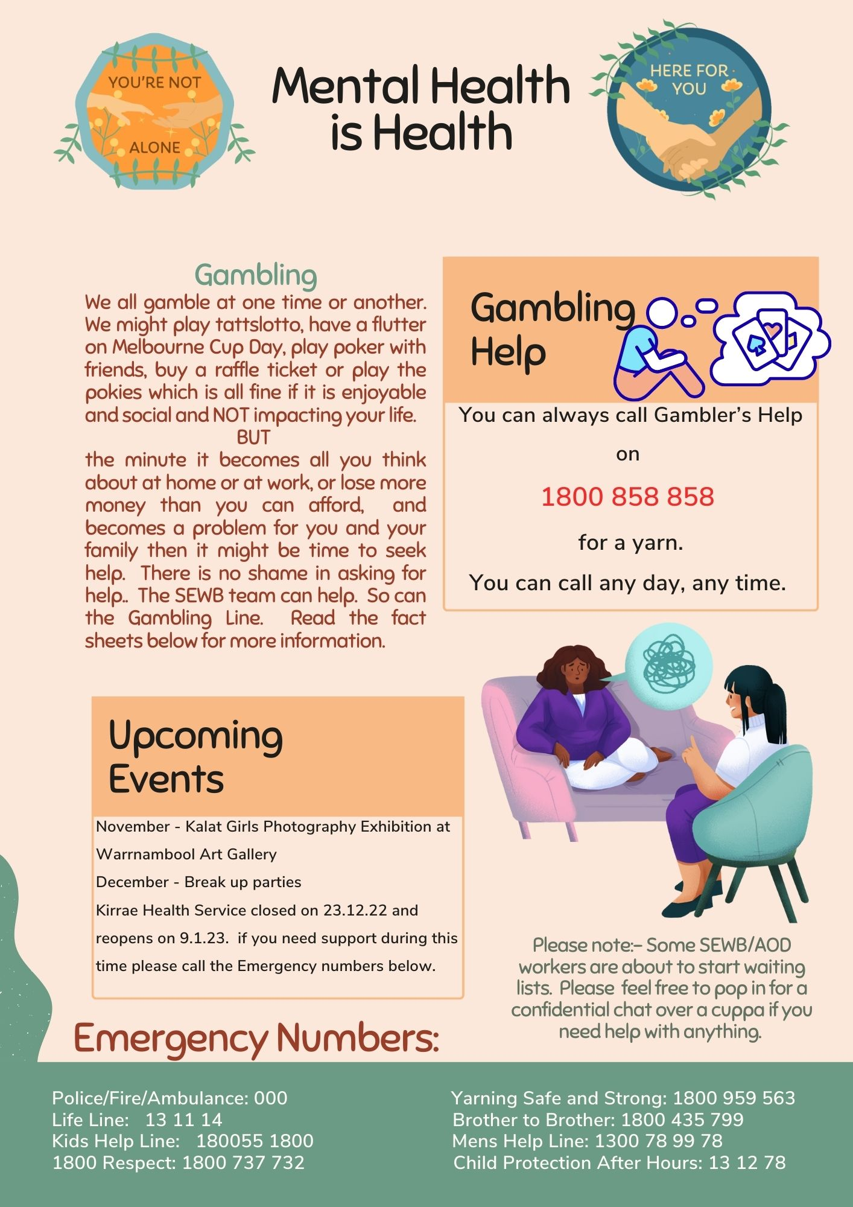

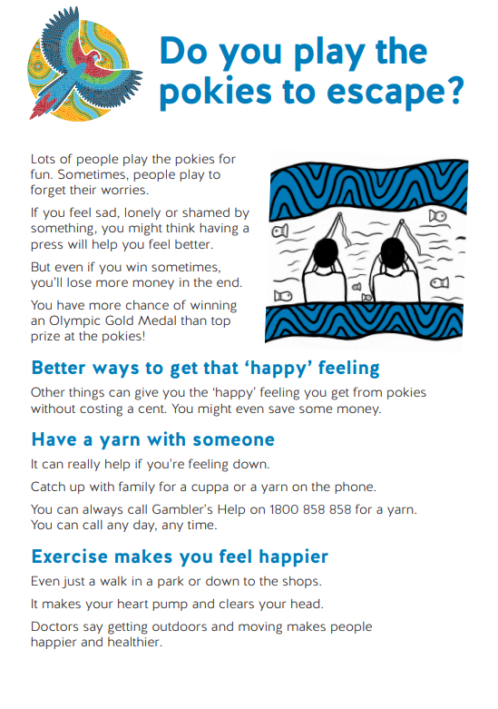

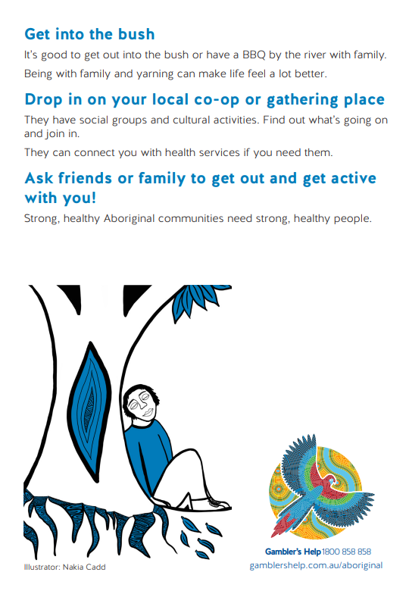

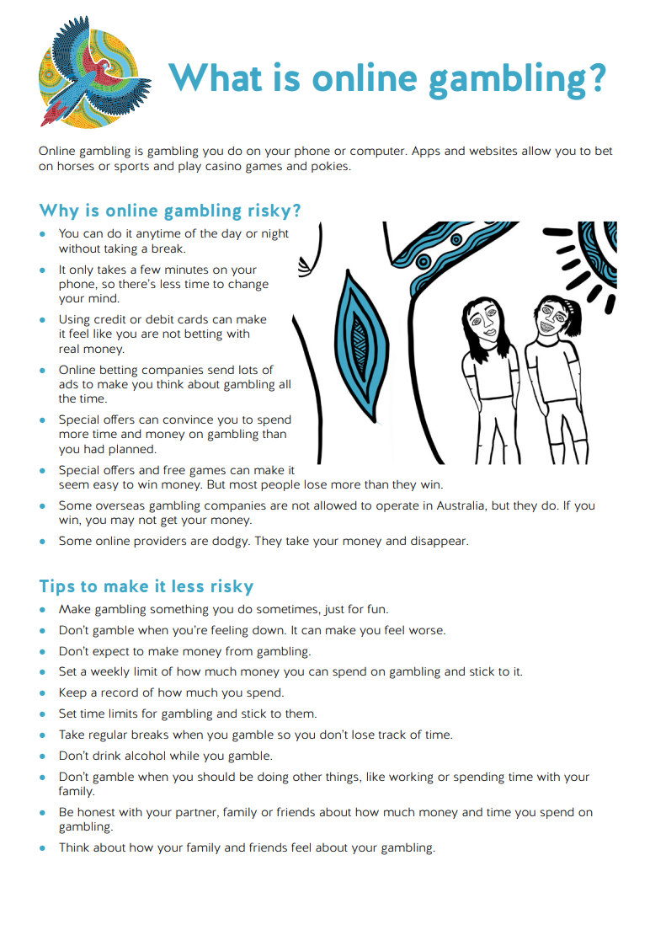
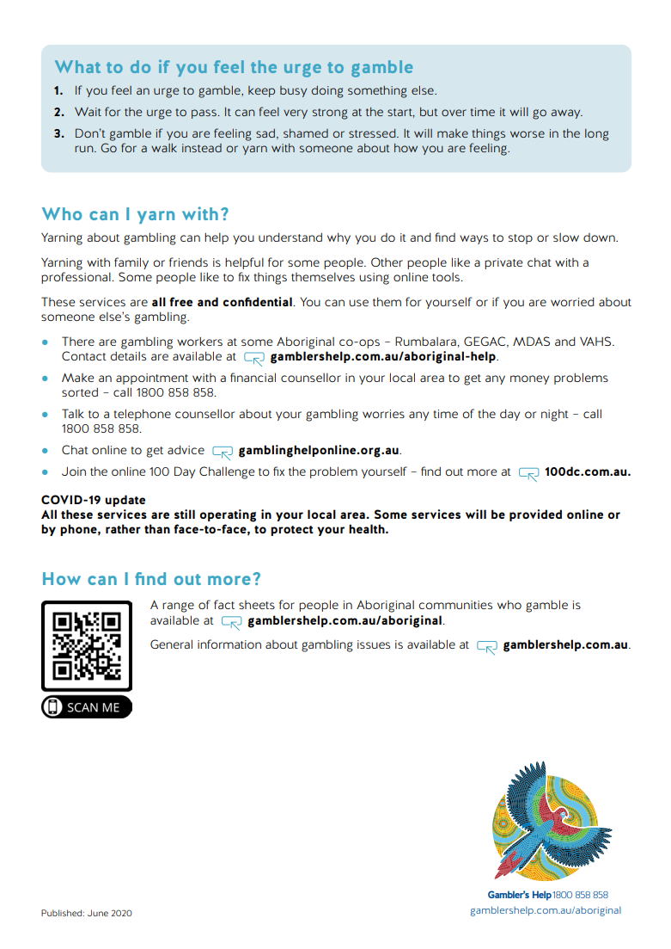
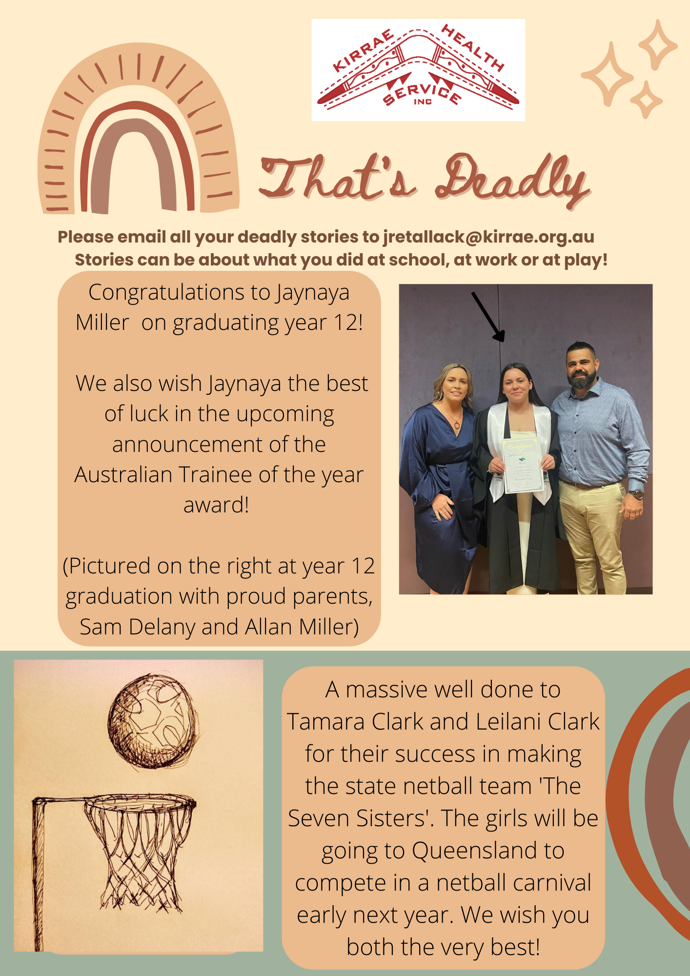
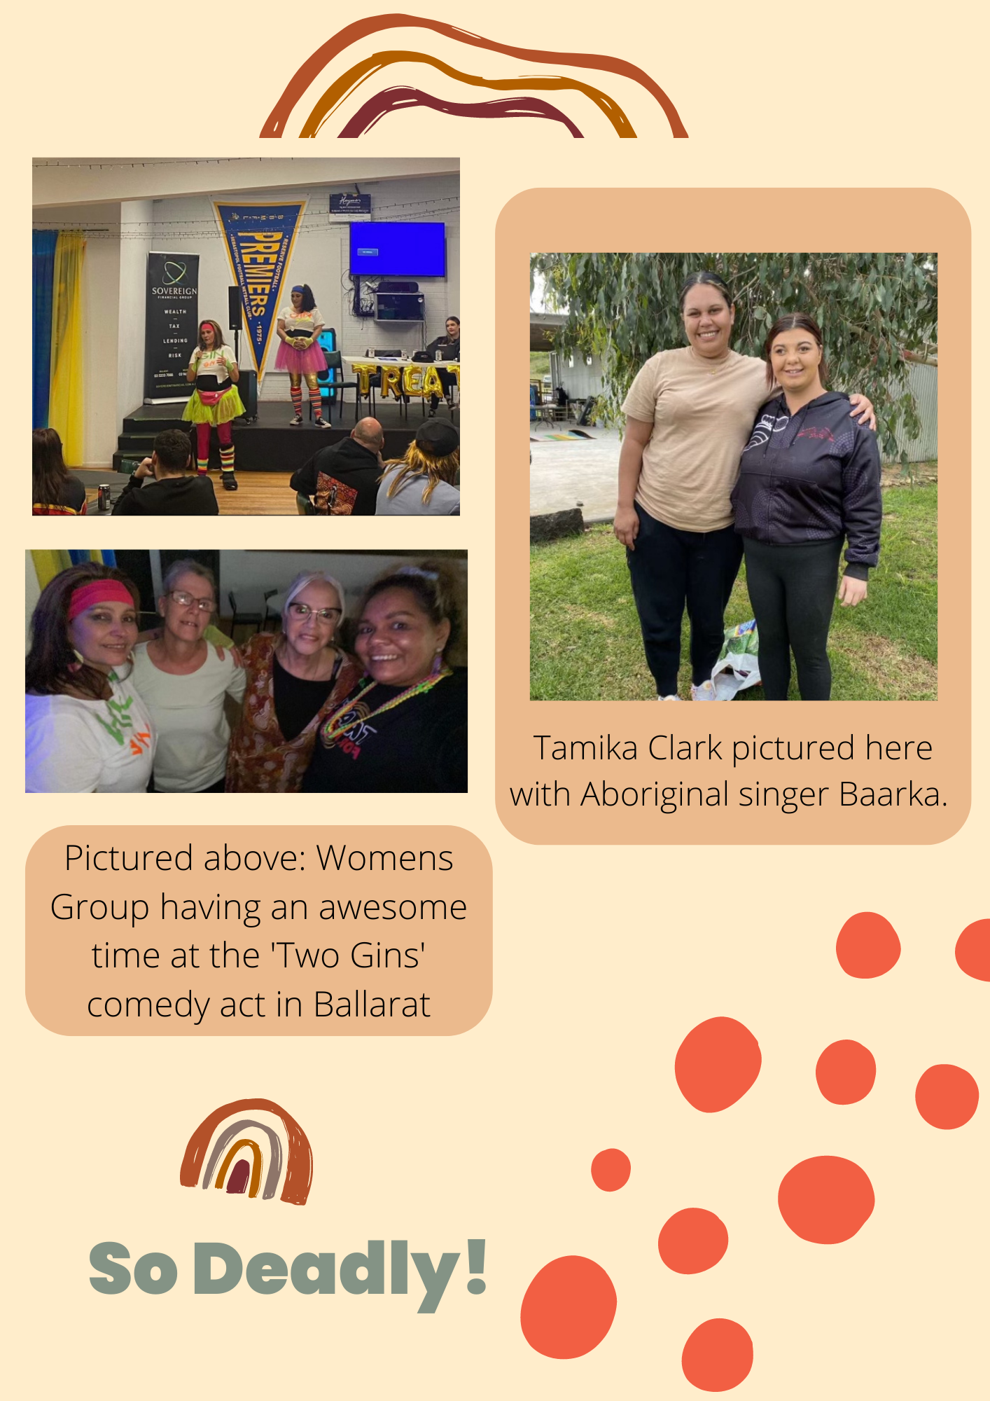
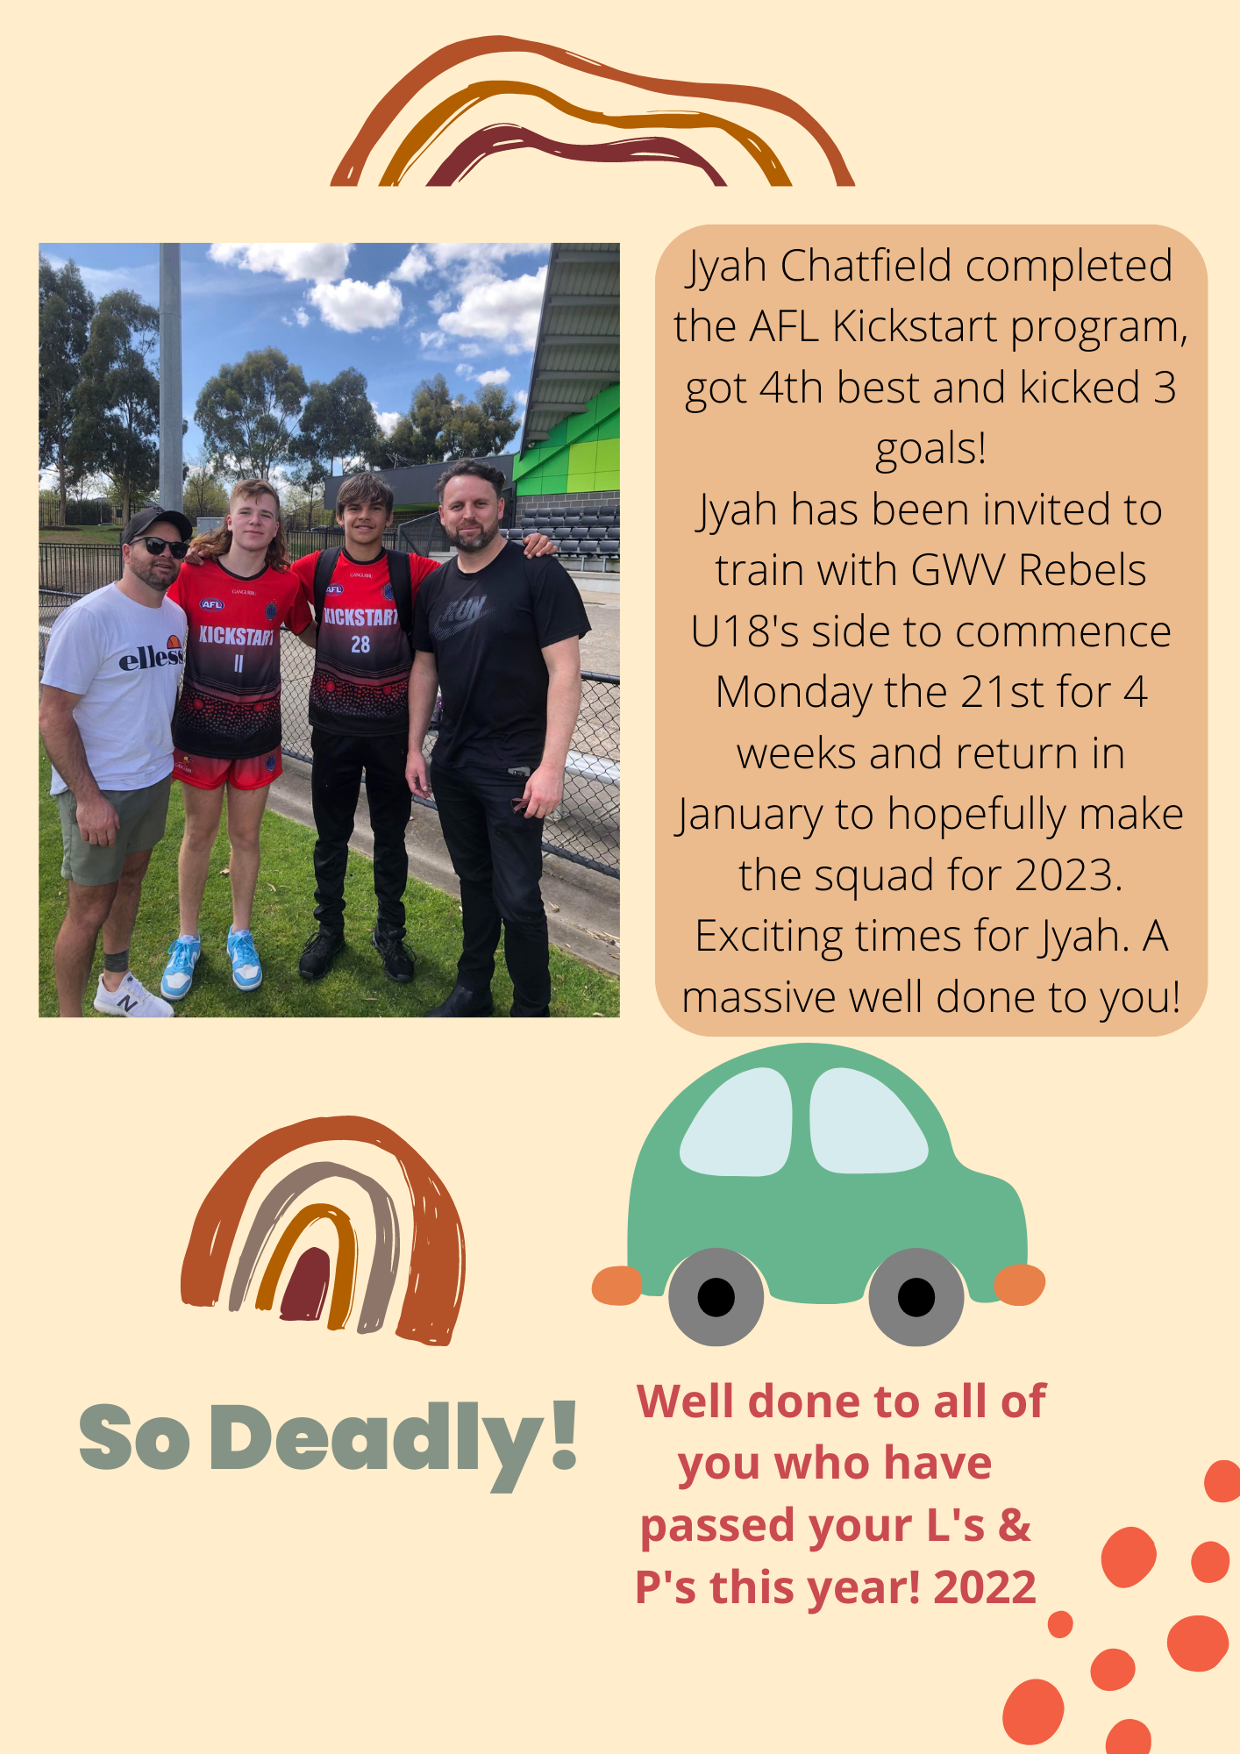
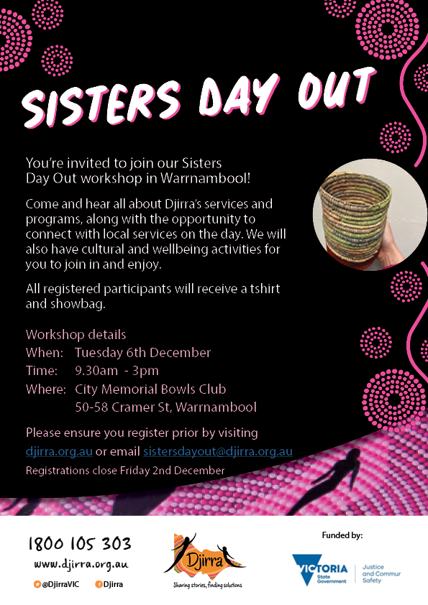
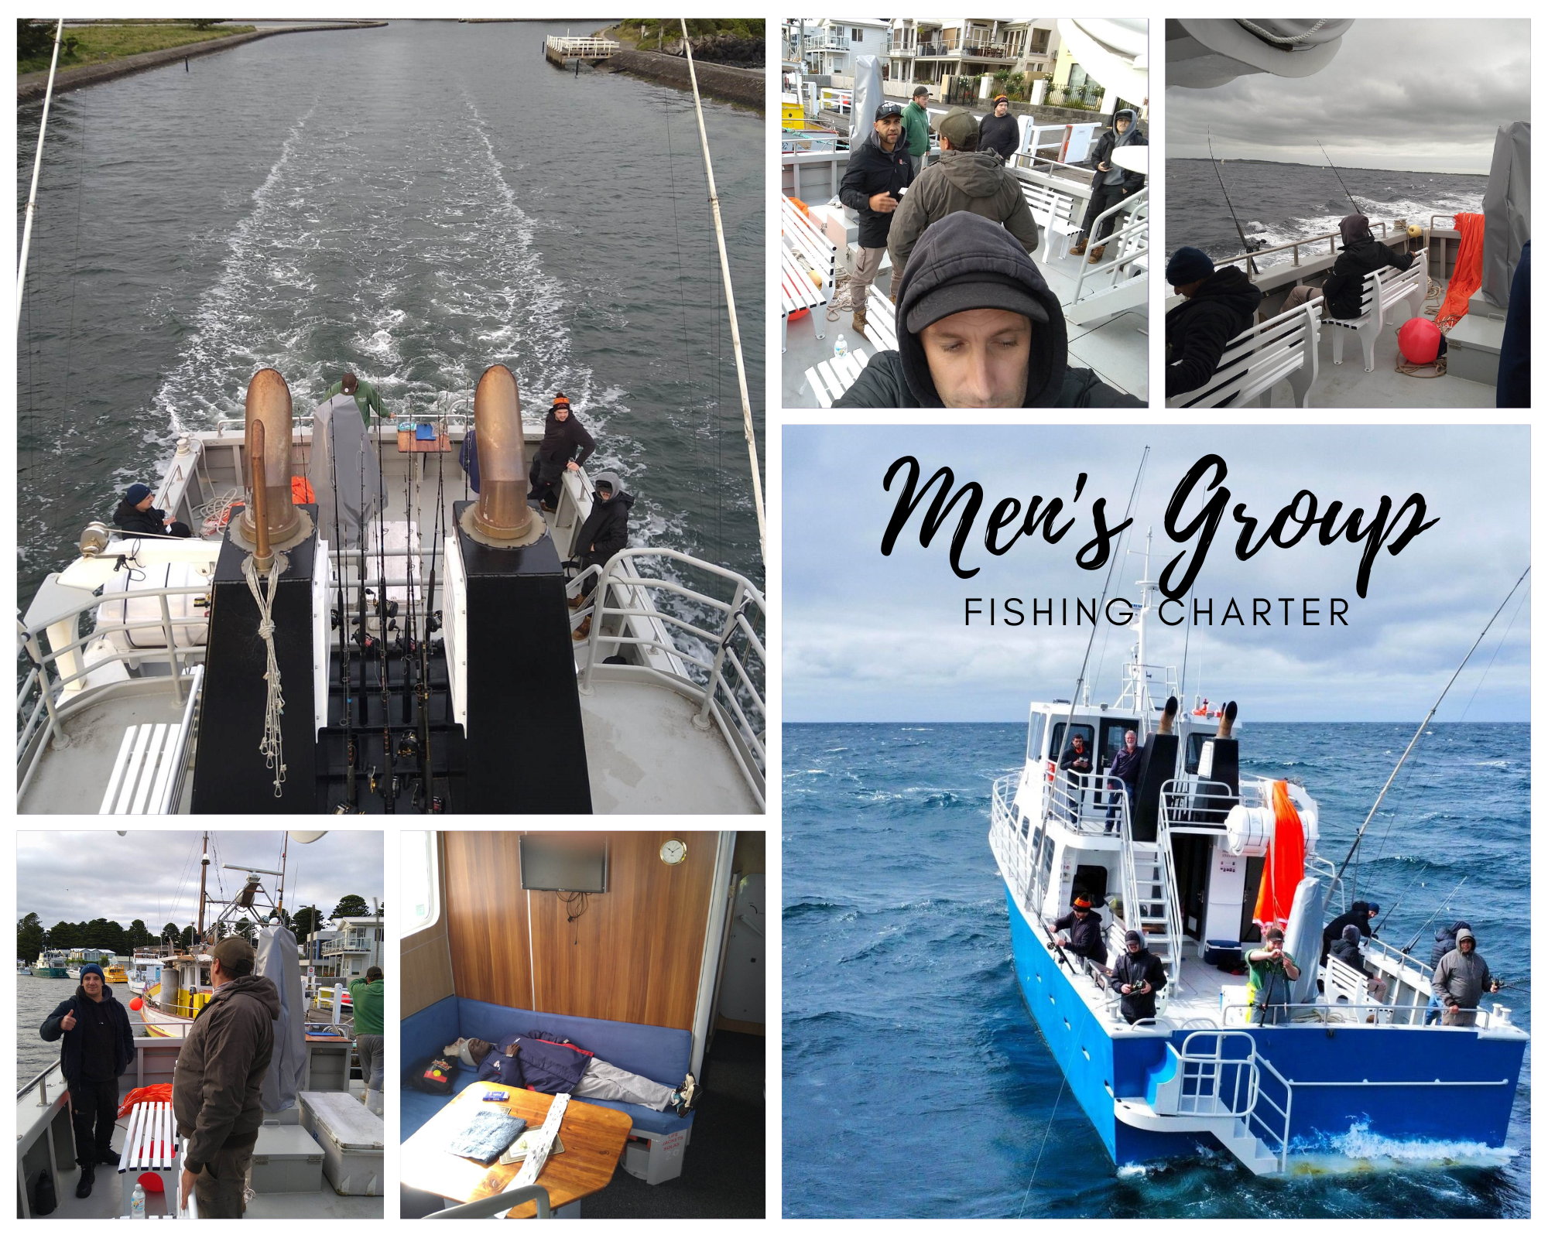
MEN’S’GROUP

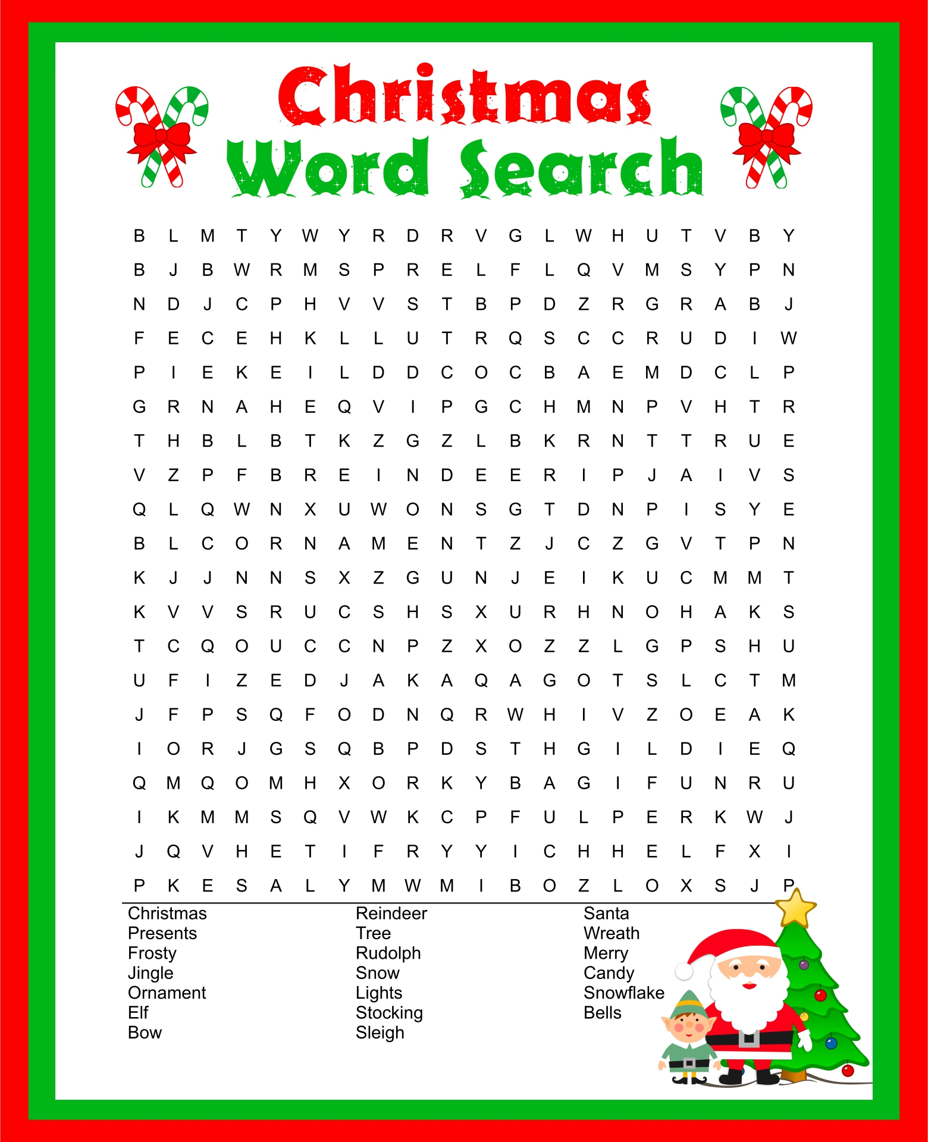

DECEMBER
Sunday | Monday | Tuesday | Wednesday | Thursday | Friday | Saturday
27 | 28 | 29 | 30 | 1 | 2 | 3
4 | 5 | 6 | 7 | 8 | 9 | 10
Dr Chandan
S/S Lunch
Dr Hall
11 | 12 | 13 | 14 | 15 | 16 | 17
 |  | Playgroup Xmas Break Up | Community Xmas Lunch Bingo | Dr Hedgland
18 | 19 | 20 | 21 | 22 | 23 | 24
 |  |  |  |  | KHS CLOSED
25 | 26 | 27 | 28 | 29 | 30 | 31
Christmas Day | Boxing day | KHS CLOSED | KHS CLOSED | KHS CLOSED | KHS CLOSED

Do you have any feedback on our:

- Services?
- Ideas?
- Suggestions?

Let us know!

Phone: (03) 5567 1270
Email: info@kirrae.org.au
Or Drop in feedback to reception

Kirrae Health Service Inc.

1 Kirrae Ave
Purnim, Vic, 3279

Phone:
03 5567 1270

Fax:
03 5567 1376

E-Mail:
info@kirrae.org.au

We’re on Facebook
Check for information
update and more.

We’re on the Web!
See us at:

WWW.KIRRAEHEALTH.COM

